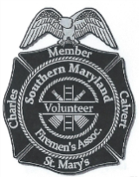
July 1, 2019
Dear Fire Rescue Supporter;
The Southern Maryland Volunteer Firemen’s Association has, for the last four years, sponsored a benefit golf tournament supporting the National Fallen Firefighters Foundation, a 501c3 non-profit foundation. This foundation provides support to families and fire departments that have suffered a “Line of Duty Death”. They also provide a number of programs to support the reduction of firefighter deaths, injuries and a major focus on reducing the cancer in the fire service. They provide programs such as children’s camps as well as providing scholarships for the children of our fallen heroes. Annually, the foundation conducts a ceremony in October at Emmitsburg, Md. which brings all of the families of our fallen firefighters from the previous years for recognition and placement of their names at the National Fallen Firefighter’s Memorial located at the National Fire Academy and a very moving memorial service is held at the chapel near the Memorial site.
There are approximately 24 such tournaments across the nation, and I say proudly, ours is the only one in Maryland. All four of our events have been very successful with sold out attendance and strong corporate support. We are currently in the planning stages for our fifth tournament to be held on September 18, 2019 at Wicomico Shores Golf Course. While we have been successful in our efforts, we continue to reach out to the Southern Maryland business community for additional support of this very worthy cause. Our sponsor levels range from $100.00 to $2,500.00 and each level of sponsorship is recognized in an appropriate manner.
We would respectfully request that you consider sponsorship of our fifth tournament. Should you need additional information about the event, please feel free to contact me and I would be more than glad to discuss the request or meet with you to answer any questions you may have. My contact information is below.
Respectfully,
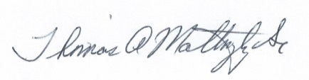
Thomas A. Mattingly Sr.
Past President, So. Md. Volunteer Firemen’s Association

Cell: 301-481-7702
e-mail: tammsfa@bellatlantic.net
Mail: P.O. Box 173, Leonardtown, Md. 20650

